23CSE111 OBJECT ORIENTED PROGRAMMING
S2 B.Tech CSE
Department of Computer Science and Engineering
Amrita School of Computing, Amritapuri Campus
CASE STUDY
PHASE – 2 (Design)
Architectural Modelling (CO2)

Group No : D14
Team Members :
Roll No | Student Name
AM.SC.U4CSE25321 | Harinarayan N
AM.SC.U4CSE25350 | Sivatheerdha C A
AM.SC.U4CSE25358 | Vyshnavi Rajith
AM.SC.U4CSE25331 | Thanmai Mathi
AM.SC.U4CSE25307 | B Dinesh

- Problem Title : Blood Bank Management System

STRUCTURAL DESIGN
- Class diagram (draw class diagram that shows different classes and their relationships. Use UML notations)
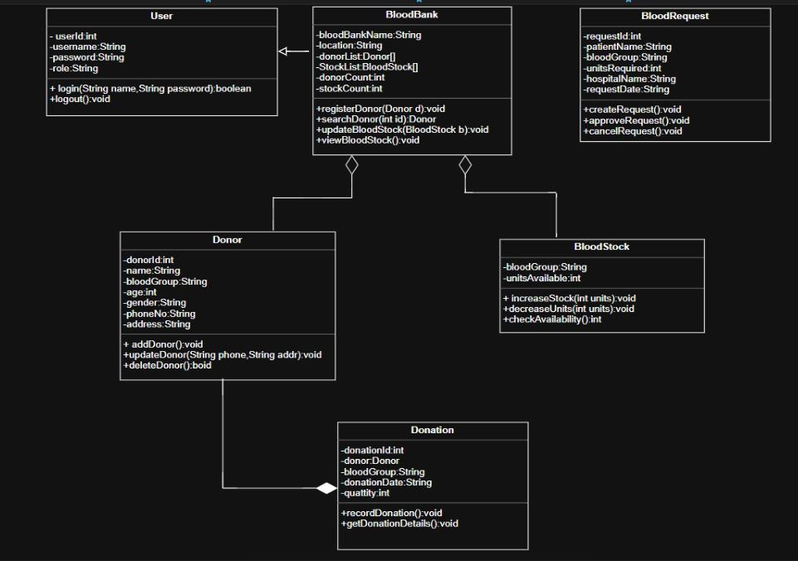

BEHAVIUORAL DESIGN
- Use-case diagram
- List of actors
- User (Blood Bank Staff)
- Donor
- Patient
- List of use-cases
- Login: The blood bank staff (User) enters their username and password to authenticate and gain access to the system.
- Logout: The authenticated User logs out of the system to end their session securely.
- Add Donor: The User registers a new donor by entering their personal details such as name, age, blood group, phone number, and address into the system.
- Update Donor: The User updates an existing donor’s contact details such as phone number or address when changes occur.
- Delete Donor: The User removes a donor record from the system when the donor is no longer eligible or available.
- Record Donation: The User records a blood donation event by linking a donor, specifying the blood group, quantity donated, and the date of donation.
- Get Donation Details: The User retrieves the details of a recorded donation, including donor information, blood group, quantity, and donation date.
- Check Availability: The User checks the number of available blood units for a specific blood group in the blood bank stock.
- Manage Blood Stock: The User increases or decreases blood stock units in the system to keep inventory records accurate and up to date.
- Create Request: The User creates a blood request on behalf of a hospital or patient by specifying the patient name, blood group, units required, hospital name, and request date.
- Approve Request: The User reviews a pending blood request and approves it after verifying sufficient blood stock is available.
- Cancel Request: The User cancels an existing blood request when it is no longer needed or cannot be fulfilled.
- Use case diagram (use UML notations)
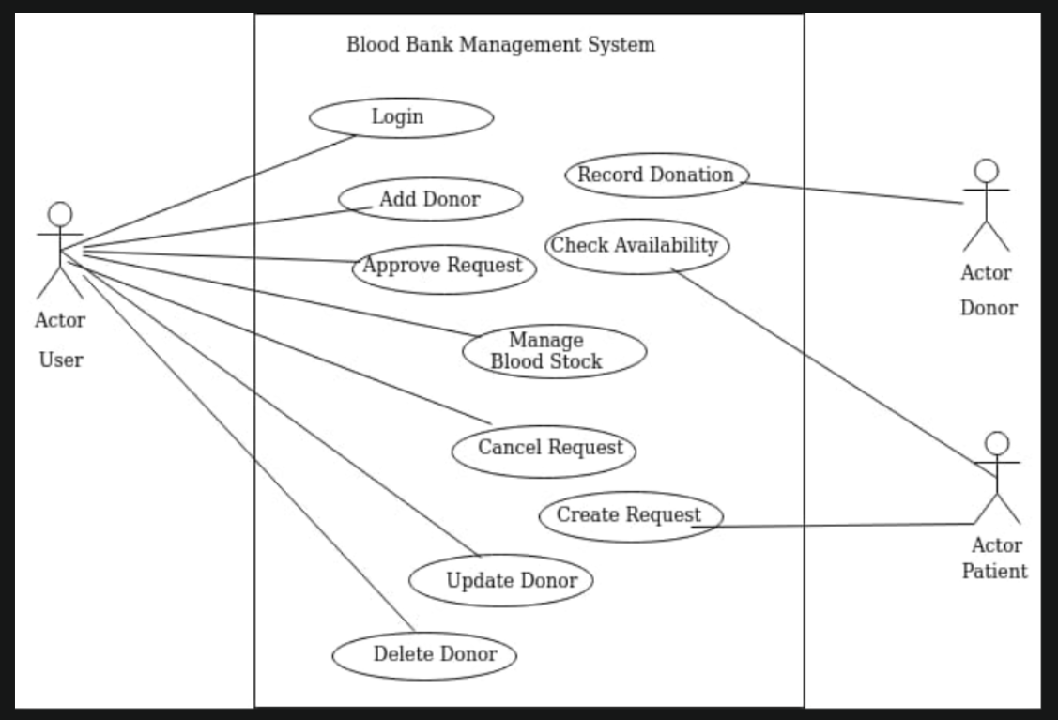
- Sequence diagram (use UML notations)
  - Use Case: Record Donation
When blood bank staff (User) records a donation, they call registerDonor() on BloodBank. BloodBank invokes addDonor() on the Donor class to store donor details and retrieves the donorId. BloodBank then calls recordDonation() on Donation, which sets all donation attributes (bloodGroup, date, quantity) and links the Donor. The Donation then calls increaseStock() on BloodStock to update the available units. A confirmation is returned to the User on successful completion.

